|  |
| --- |
| **JAVASCIPT NOTES**  **By -DARSHINI T** |

**1. What is Javascript?**

* worlds most programming language
* it is ec to learn
* allows you to implement complex features on web pages

**2. difference b/w java and javascript**

* JAVA
* Compiler
* mainly used for back-end
* for various apps
* requires Java development kit (jdk)
* JAVASCRIPT
* Interpreted
* mainly used for front-end
* mainly for web apps
* can be written in any text editor

**VARIABLES**

variables are containers for storing information or data.

**EX:**

var a = 10 // assigning values

var b = 20 // assigning values

console.log(a+b)--->// to print the values of a and b.

js can be declared in 3 ways

* using var

* using let

* using const

**1. what is the difference between var,let and const?**

**\*using var**

* function scoped
* var can be updated and re-declared within its scope
* declared without being initialized
* accesible outside the block

**EX:**

{

var a = 10

}

console.log(a) // o/p---> 10

**\*using let**

* blocked scoped
* let variables can be updated but not re-declared
* declared without being initialized

**EX:**

//let keyword cant do this

let num1 = 10

let num2 = 100

// let keyword has blockscope

{

let x=2; ---> x can not be used here

}

**\*using const**

---> blocked scoped

---> const variables can neither be updated or re-declared

---> must be initialized during declaration

**EX:**

// const keyword cant do this

const num = 10

num = 20

**Exercise 1**

* create a variable named "price" and set it to a specific price value.
* create a variable named "product" and set it to a product name.
* create a variable named "Tax" and set it to a specific tax value.
* print the name of the product.
* calculate the total price amount,including tax(total=price+tax), and then print it

|  |
| --- |
| **OUTPUT:**  darchu  120 |

**ANS:**

var price= 100

var product="darchu"

var tax = 20

console.log(product)

var sum=(price+tax)

console.log(sum)

**Exercise 2:**

* Declare a variable named “FruitName”
* Declare a variable named “count”.
* Declare a variable named “price” and set it to the price of the fruit.
* Declare a variable named “total” and calculate it by multiplying the “count” by the “price”.
* Print the name of the fruit.
* Print the total price of the fruits.

|  |
| --- |
| **OUTPUT:**  apple  1200 |

**ANSWER:**

var fruitname="apple"

var count=6

var price=200

var total=count*price

console.log(fruitname)

console.log(total)

**KEYWORDS**

Js has a set of reserved keywords that have predefined meanings and cannot be used as identifiers

**EX:**

Var,let,cont,if,switch,for etc…,

**COMMANDS:**

* Single-line command 🡪 //
* Multi-line command 🡪 */ /*

**OPERATORS:**

* +,-,*,/,% 🡪 operators
* Increment operators

++a 🡪 pre-increment

a++ 🡪 post-increment

* Decrement operators

--a 🡪pre-decrement

a-- 🡪post-decrement

**DATATYPES**

In JavaScript, a datatype defines the type of data a variable can hold, such as numbers, strings, or booleans.

There are 2 types in javascript

1. Primitive datatype

* Number
* String
* Boolean
* Null
* Undefined

1. Non-Primitive datatype

* Object
* Array

**EXAMPLE:**

**//Example 1:**

console.log(typeof("a"));

**output:** string

**//Example 2:**

console.log(typeof(10))

**output:** number

**//Example 3**

var a

console.log(a)

**output:** undefined

**//Example 4**

var a=true

console.log(a)

**output:** true

**//Example 5**

console.log(typeof(true))

**output:**Boolean

**Js-FUNCTIONS**

* A js function is a block of code designed to perform a particular task.
* A js function is executed when “something” invokes it (calls it)

|  |
| --- |
| **Syntax**:  function <functionname>(){} |

**Example:**

function java()

{

    console.log ("Js is a easy programming language")

}

java() --------------------------------------> Calling a function

|  |
| --- |
| **Output:**  30 |

**Exercise 1:**

**QUESTION:**

Add 2 numbers

**Answer:**

var a=10

var b=20

function add()

{

    console.log(a+b)

}

add()

|  |
| --- |
| **Output:**  Favourite actor:leeminho  favourite player:dhoni  favourite movie:legend of the blue sea |

**Exercise 2:**

var favactor ="leeminho"

var favplayes ="dhoni"

var favmovie  = "legend of the blue sea"

function favourite(){

console.log("Favourite actor:" +favactor)

console.log("favourite player:" +favplayes)

console.log("favourite movie:" +favmovie)

}

favourite()

**PARAMETERS:**

* It refers to the variables or placeholders that you define when declaring a function.
* It serve as inputs to the function.
* It allow you to pass data into the function when you call it.

Example:

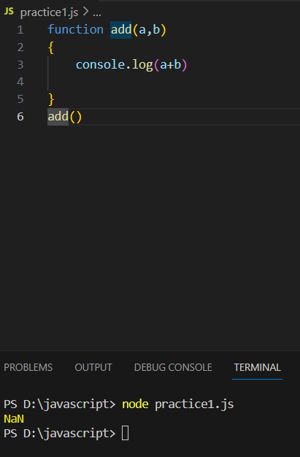

**NOTE:**

**NaN ---------------------------------------------> Not a Number**

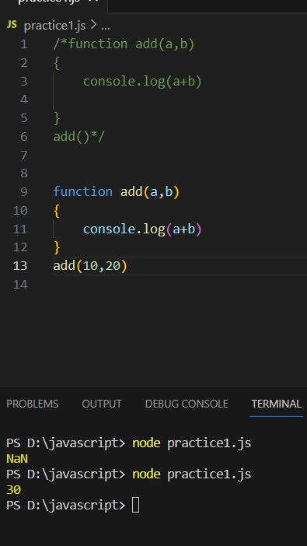

**NOTE:**

* If we calling **add()** function 10 will assign to **a** and 20 will assign to **b**
* **a** and **b** are calling as parameters.

**Exercise:**

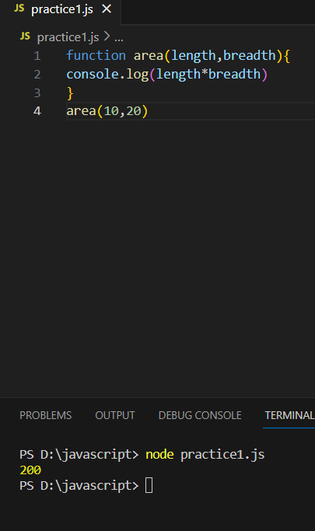

**RETURNTYPE FUNTION**

* It refers to the data type of the value that a function returns.
* It specifies the type of the result that the function produces when it is called.

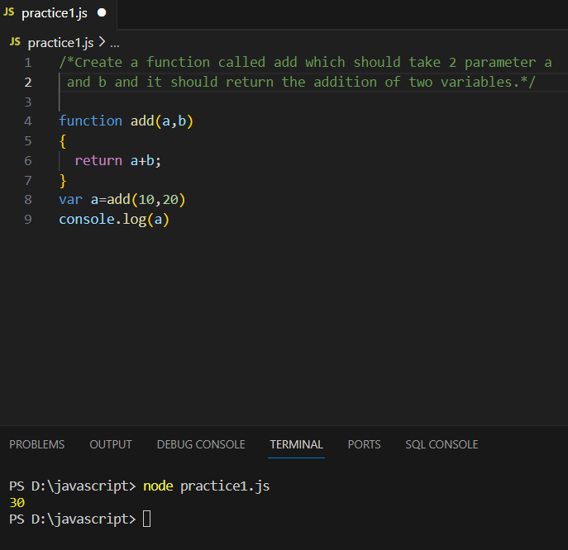

**JS if-else**

It is a conditional statement.

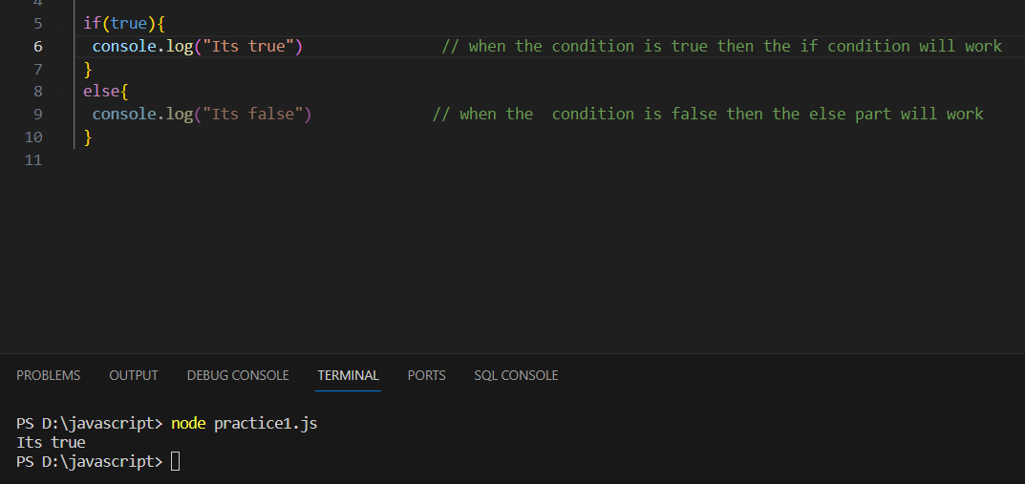

**EXAMPLE:**

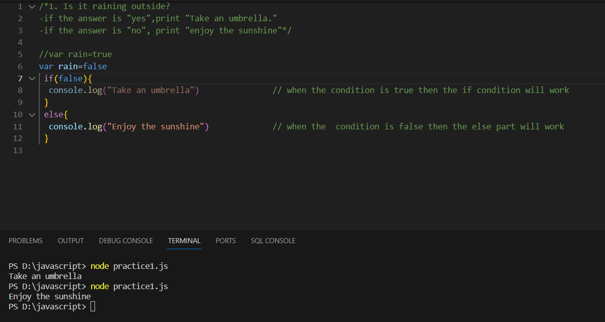

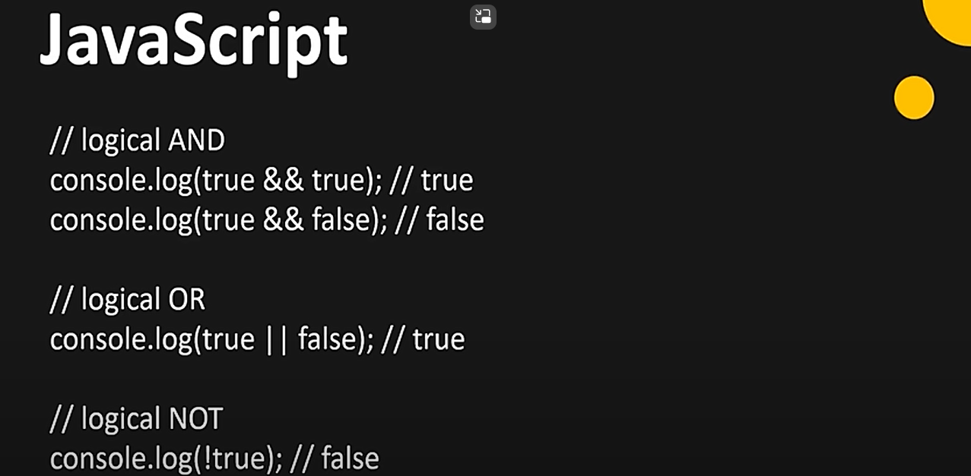

1. **LOGICAL (&&) OPERATOR**

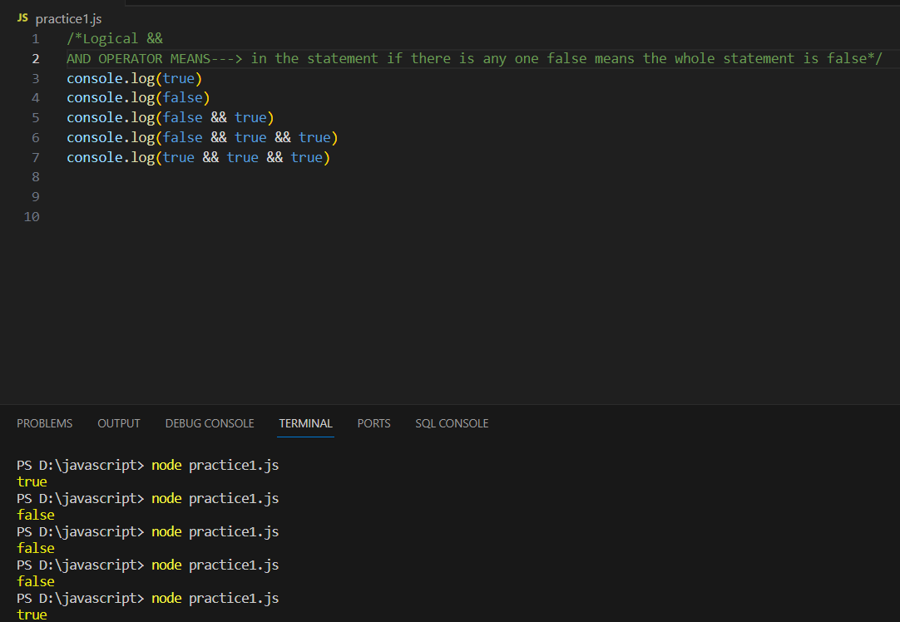

1. **LOGICAL (||) OPERATOR**

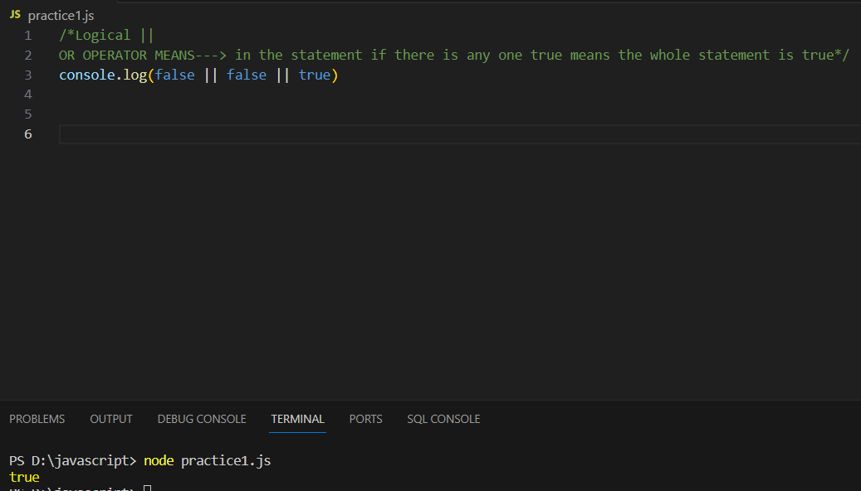

1. **LOGICAL (!) OPERATOR**

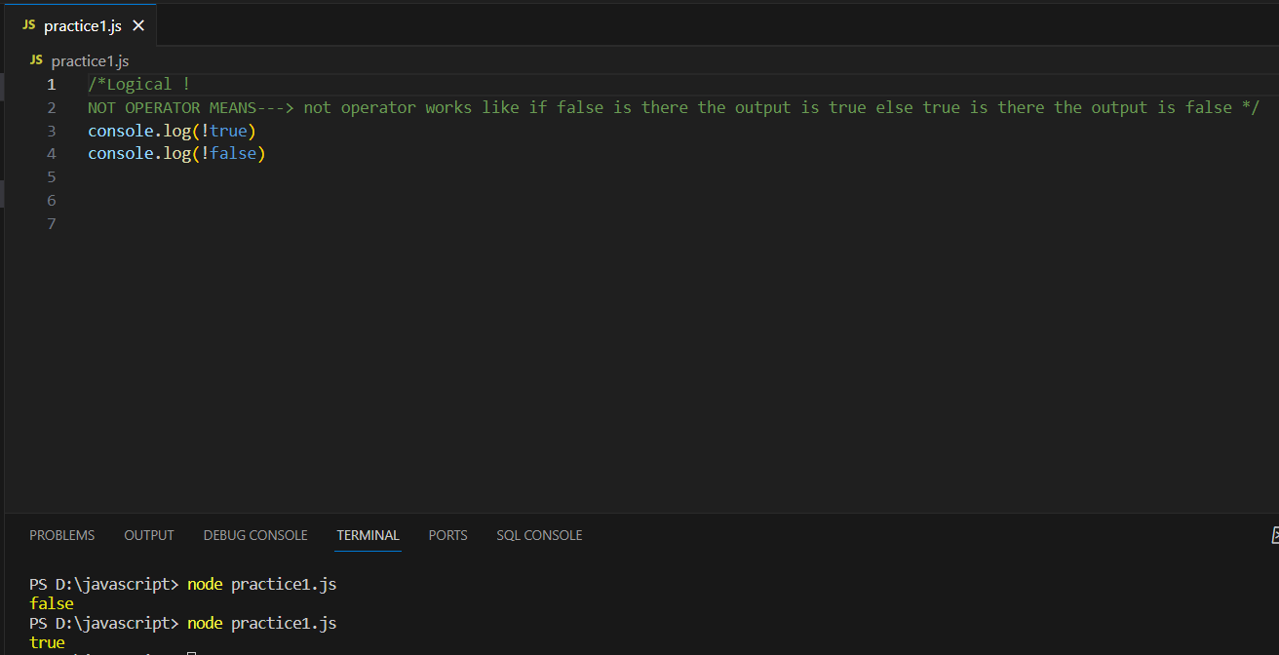

**EXERCISE:**

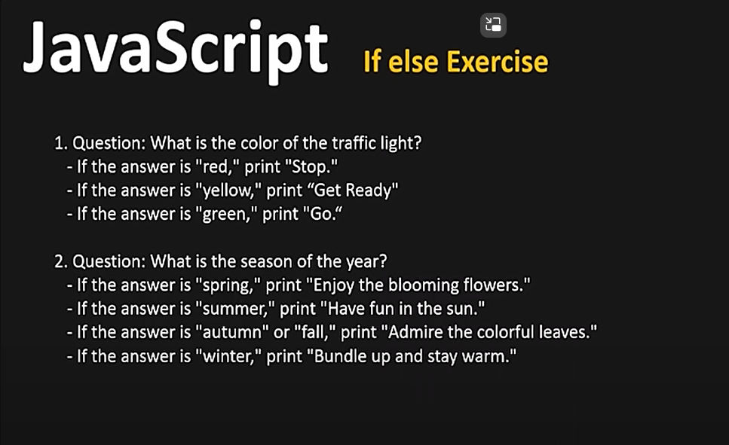 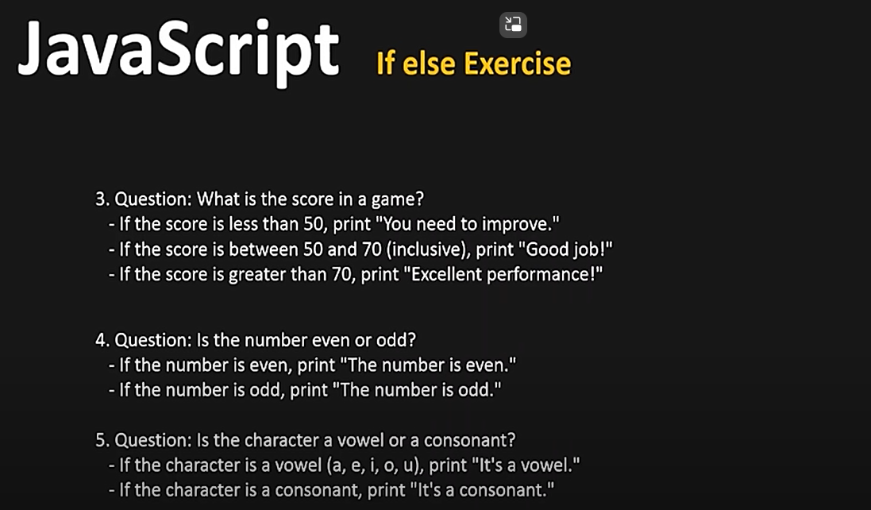

**ANSWER:**

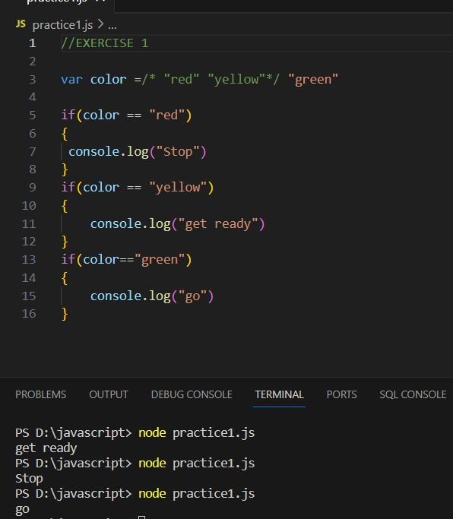 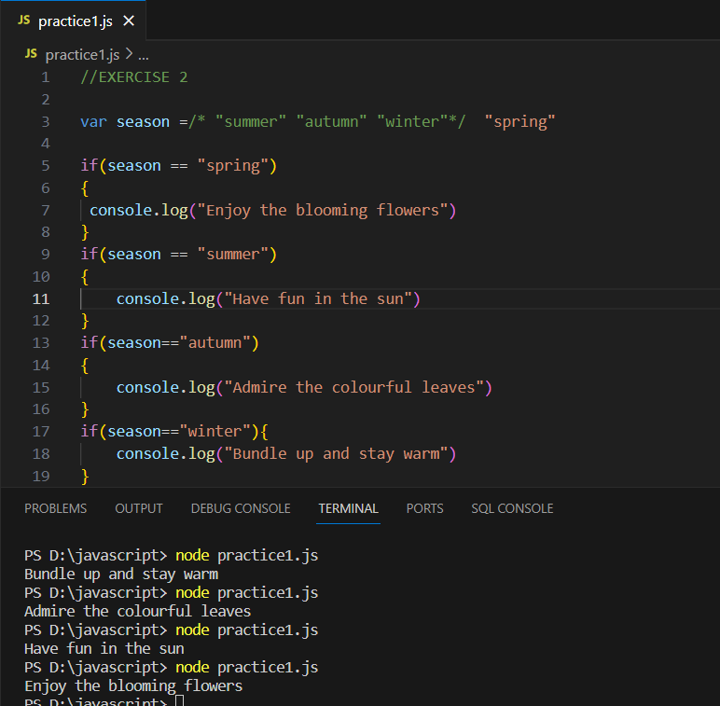

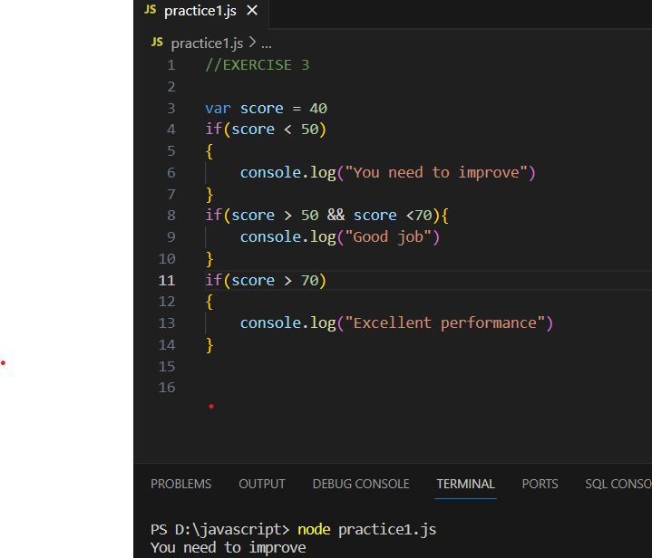 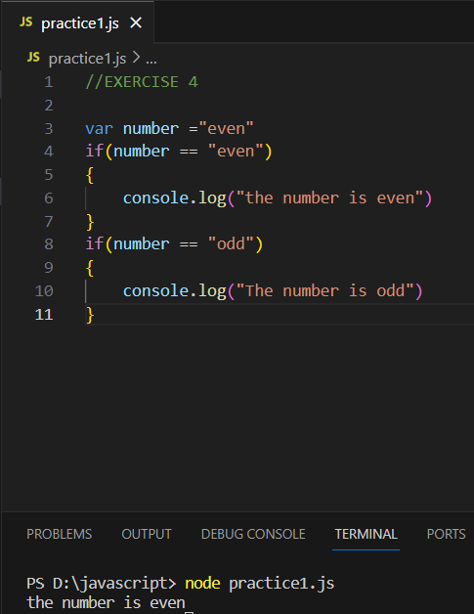

**FOR LOOP**

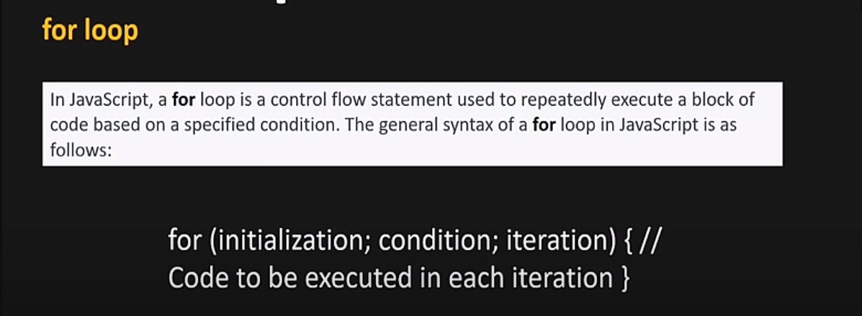

**Example**

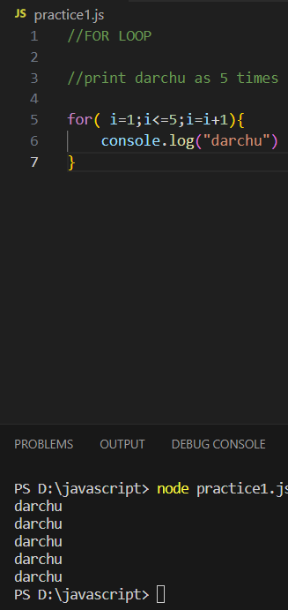 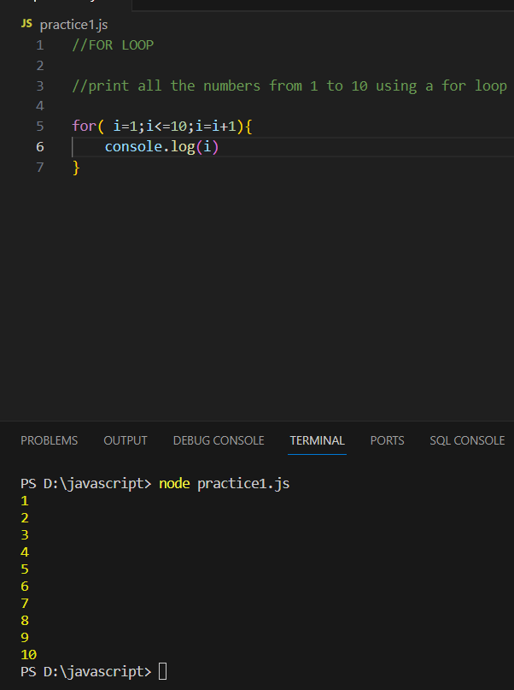 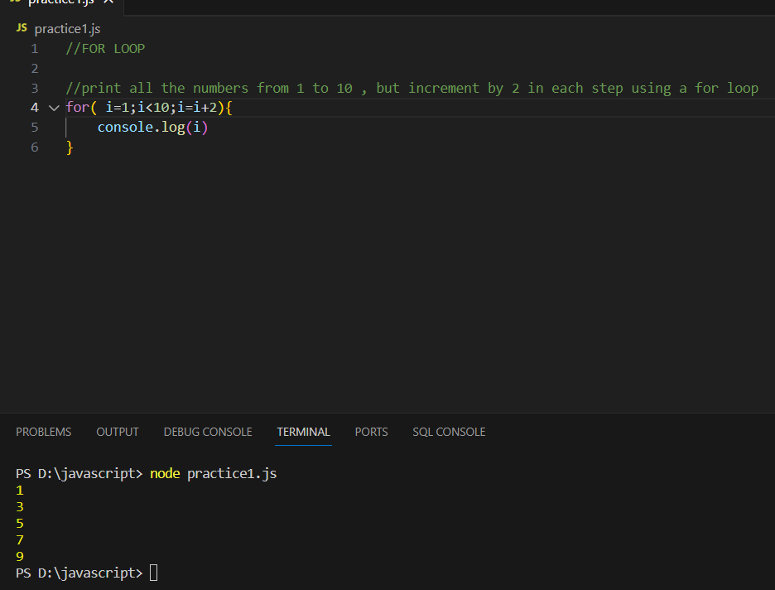

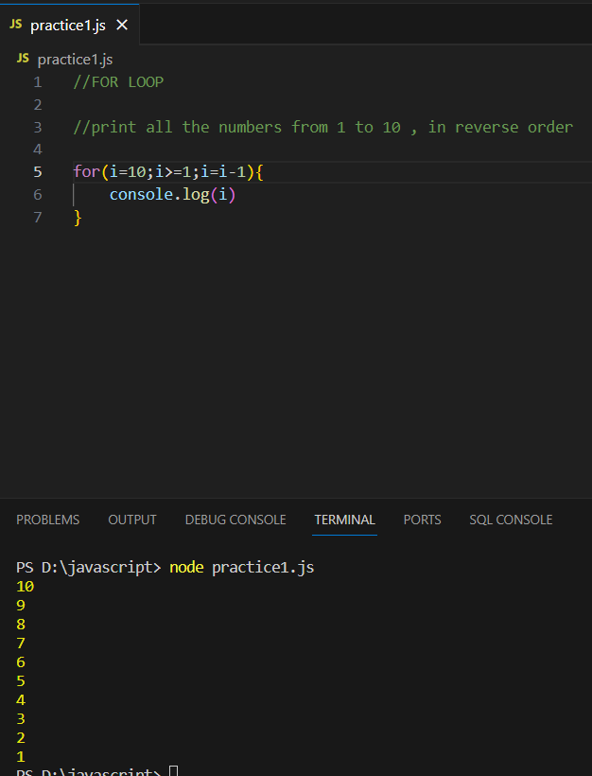 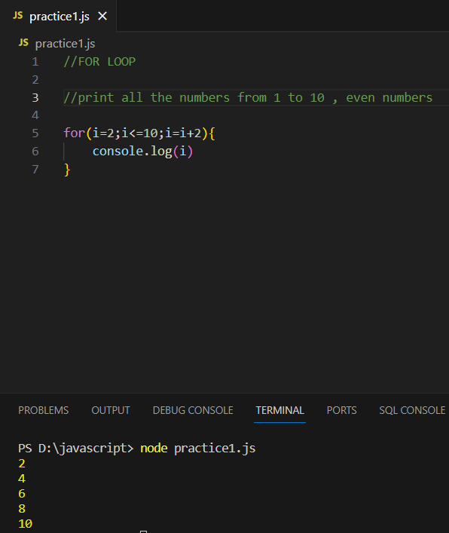 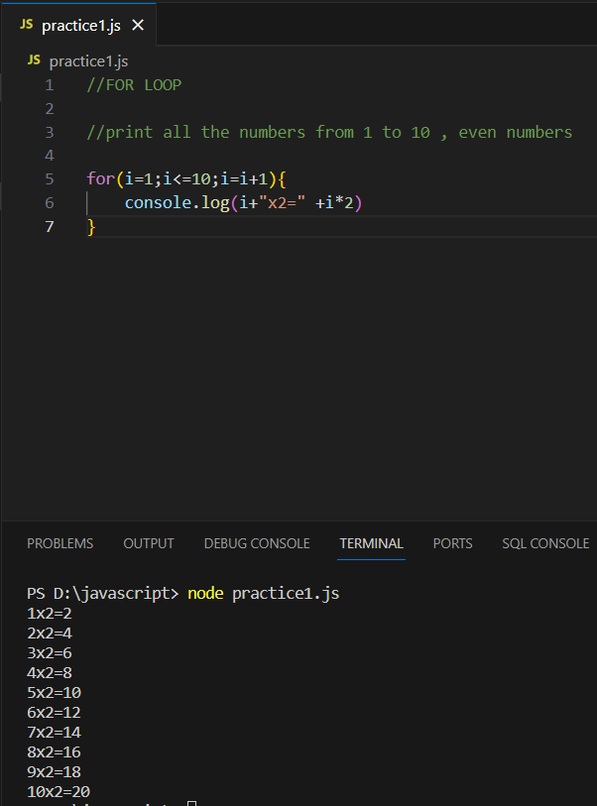

**Js.DOM Manipulation**

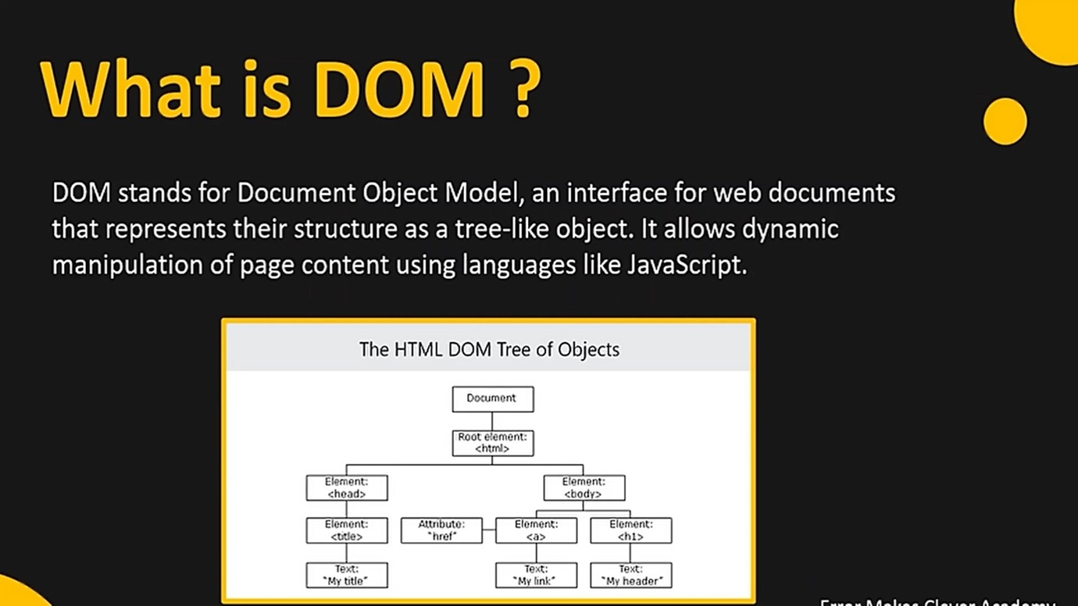

**Example:**

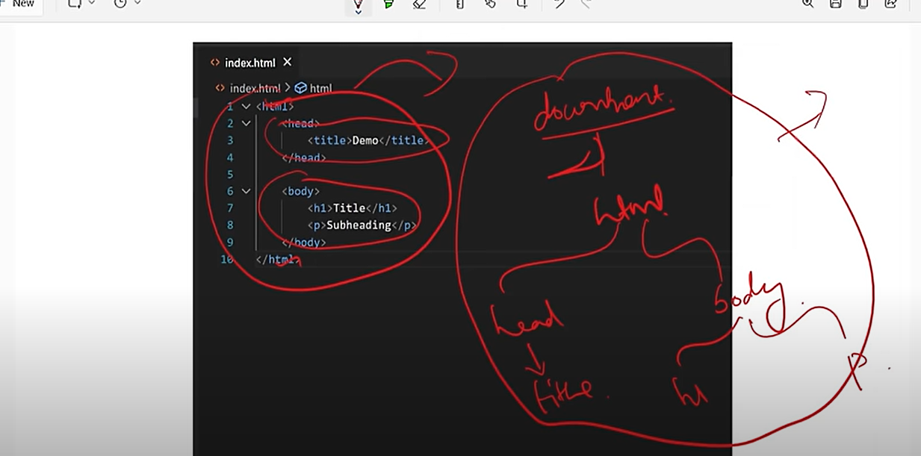

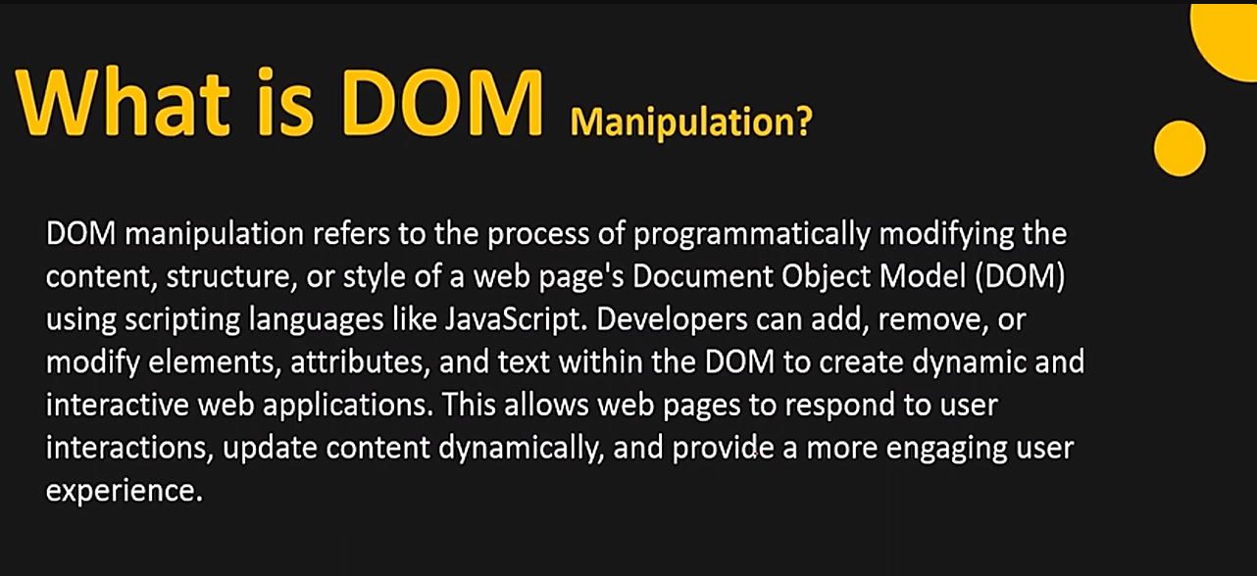

EXAMPLE

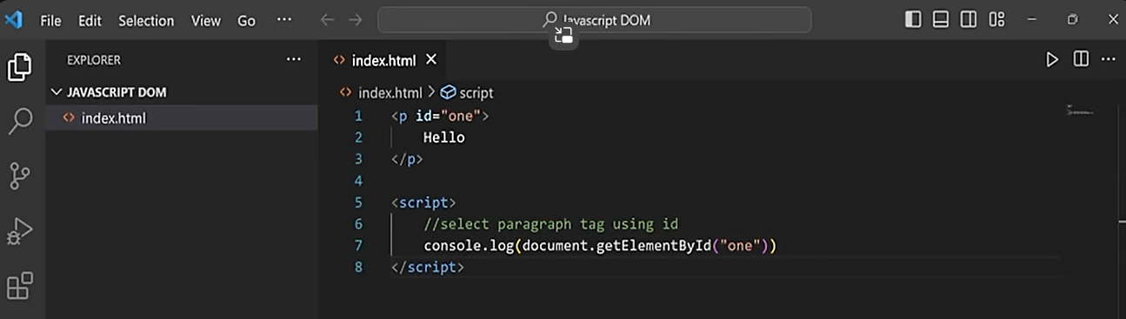

**Explanation:** You selected the paragraph id ,because of that only we get the output as

<p id=”one”> Hello </p>…we need only hello text

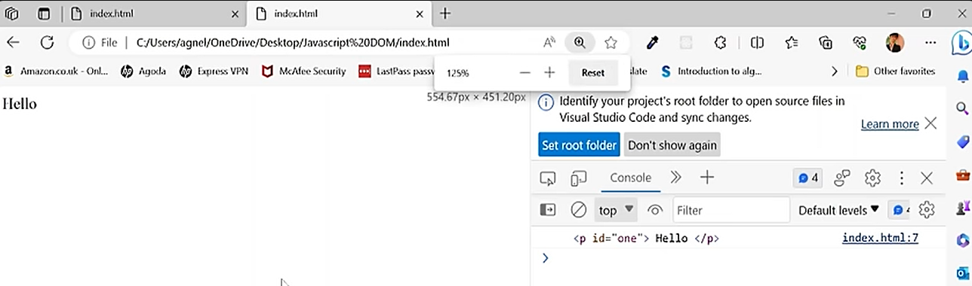



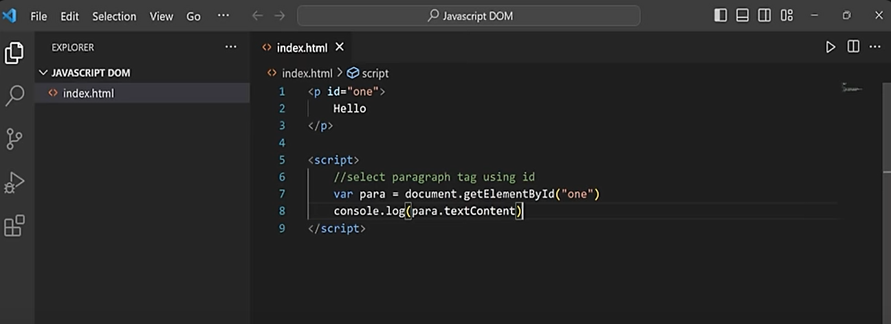

**Explanation:** We got the output as hello see above code.

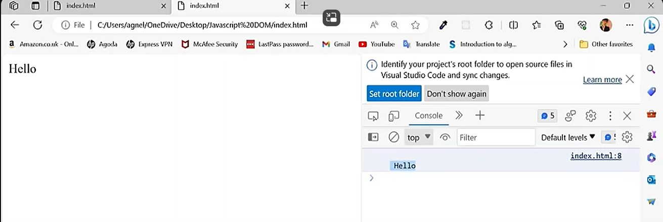

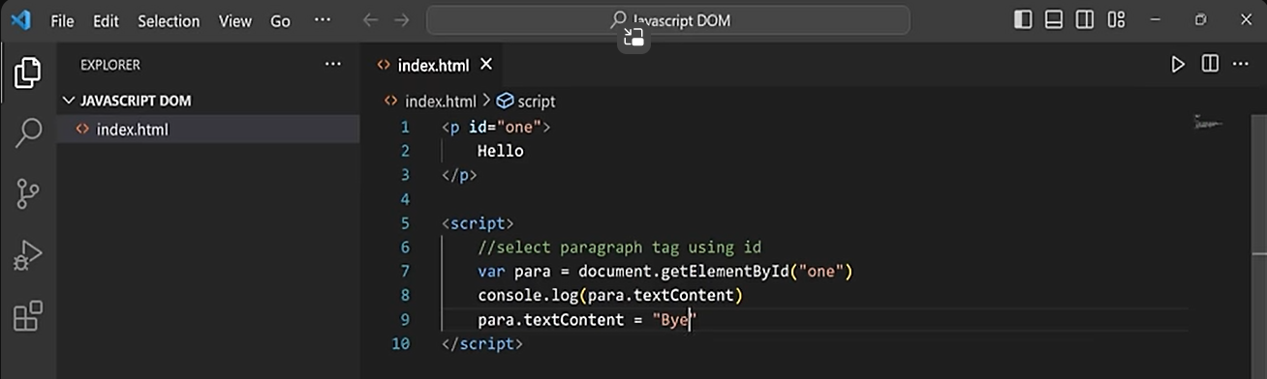

**Explanation:** We altered the **hello as bye** by using **para.textcontent**

**Para** means **<p>** this tag ….,**textcontent** means **hello**

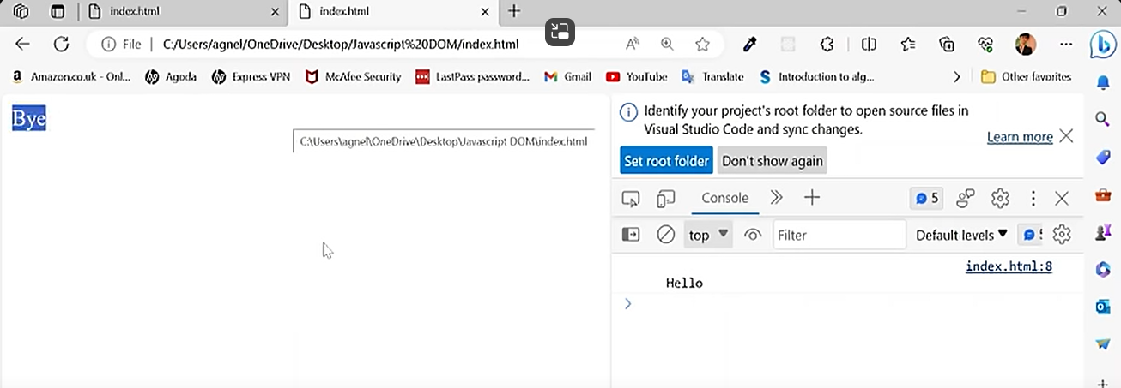

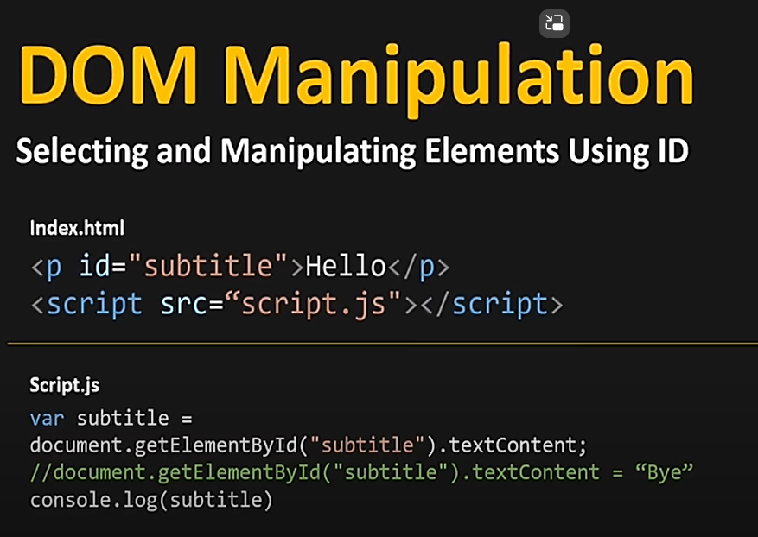 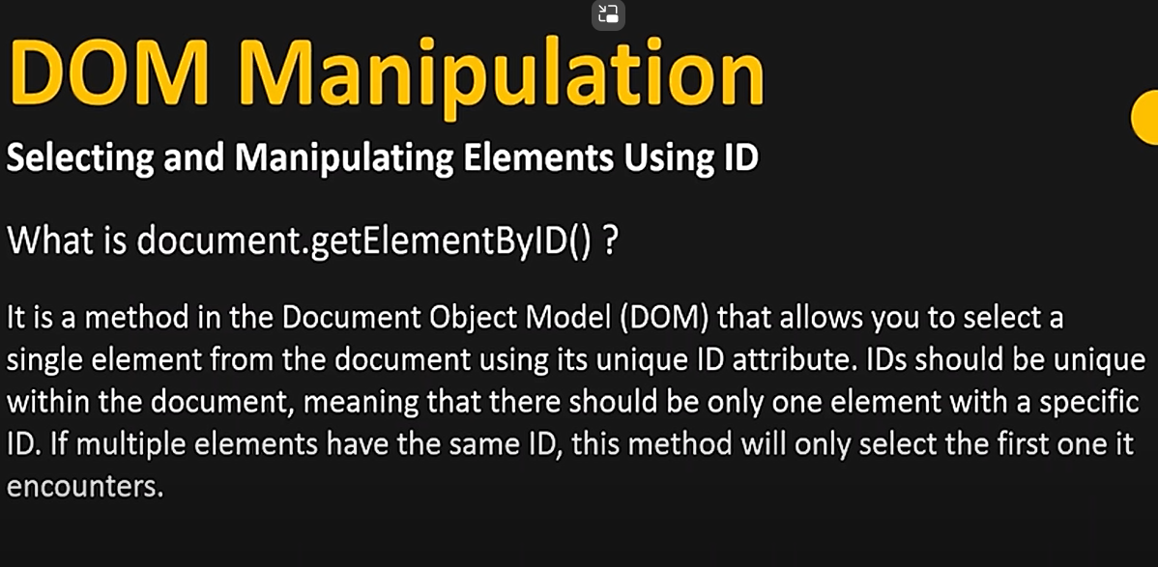

Exercise:

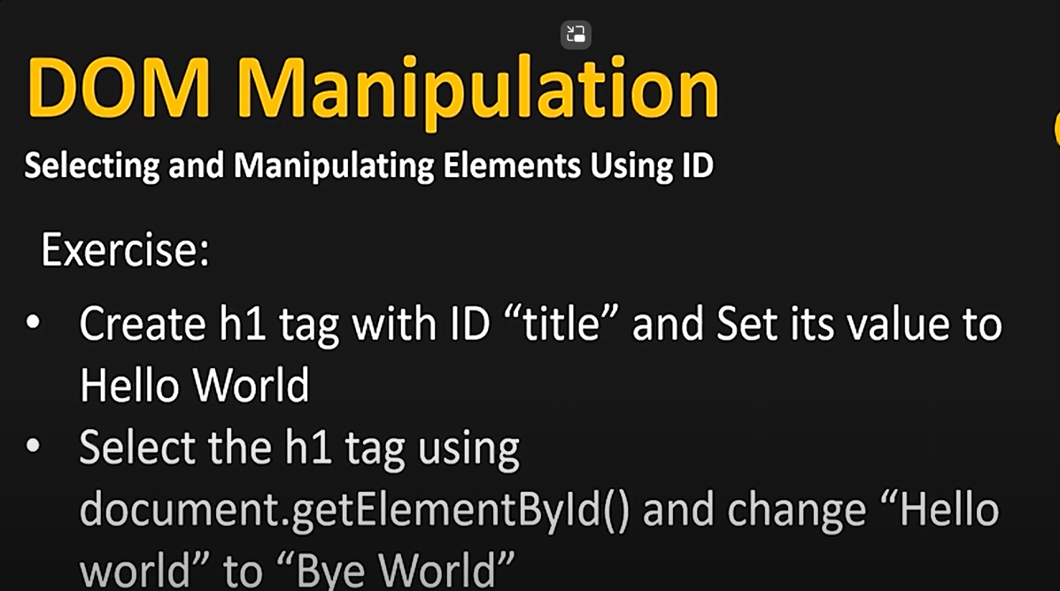

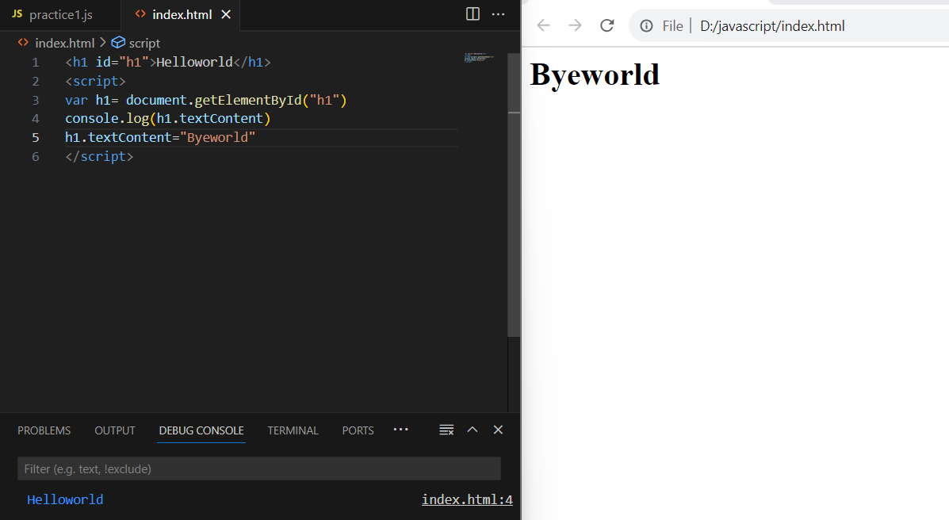

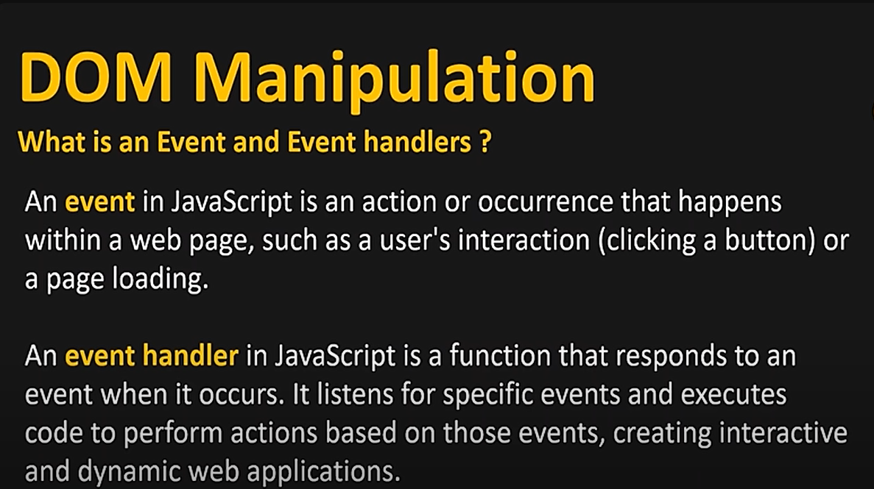

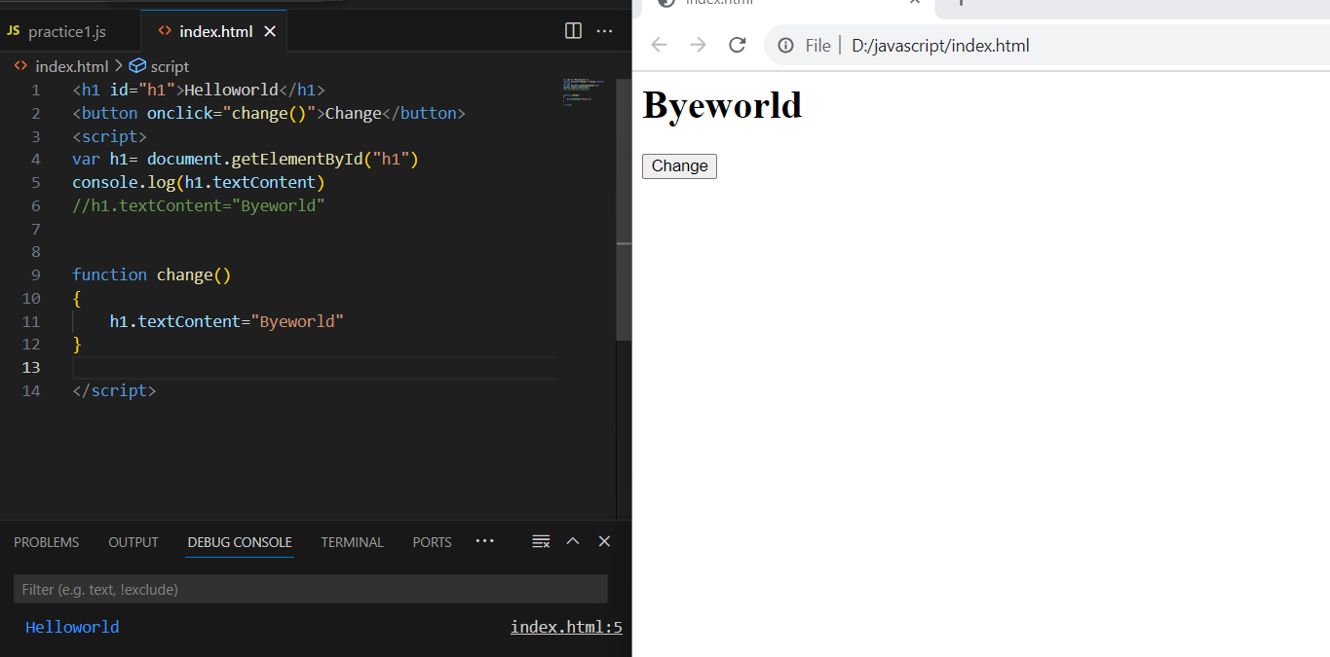

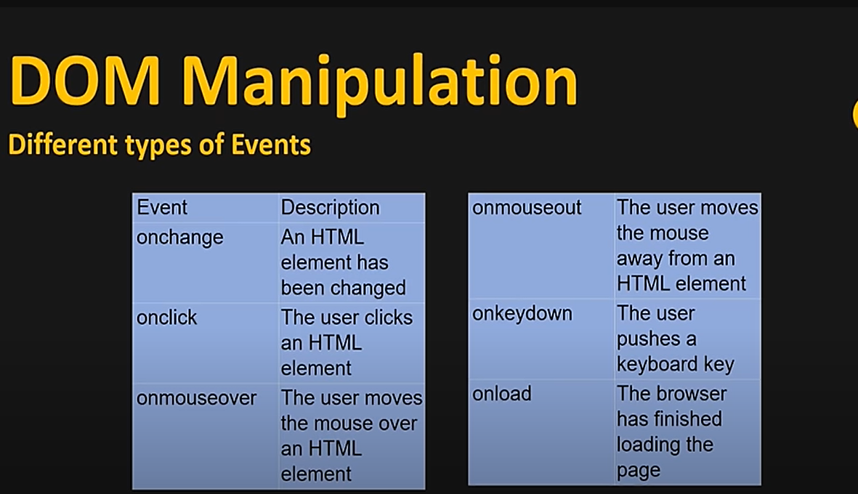

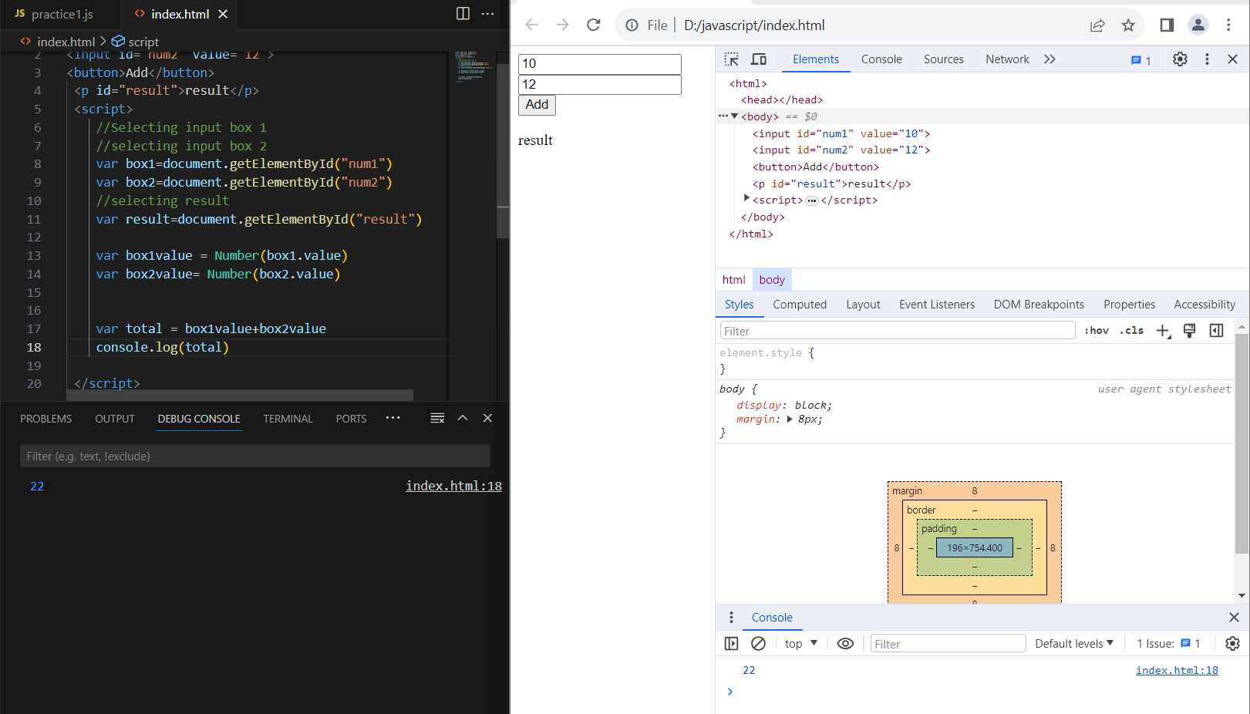

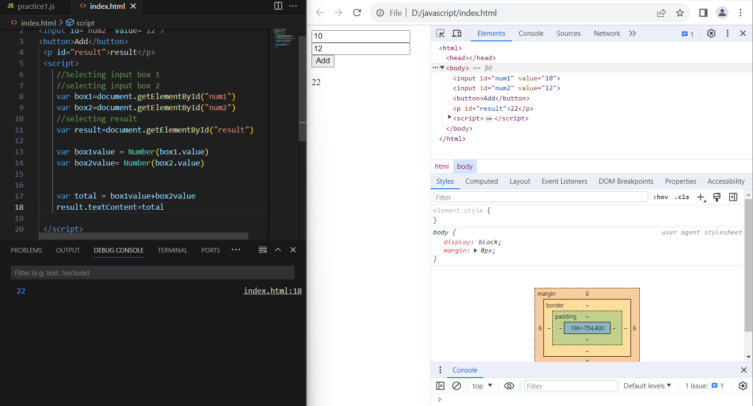

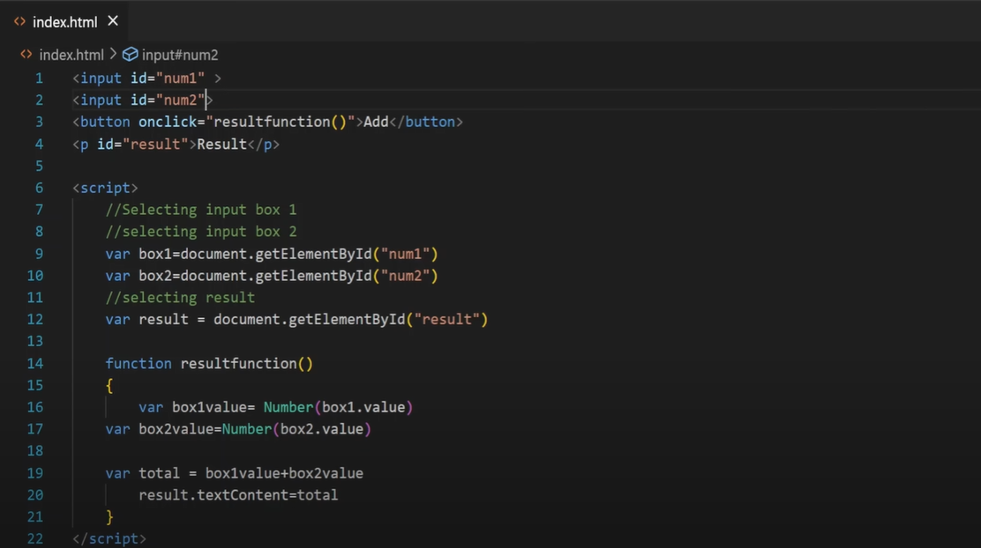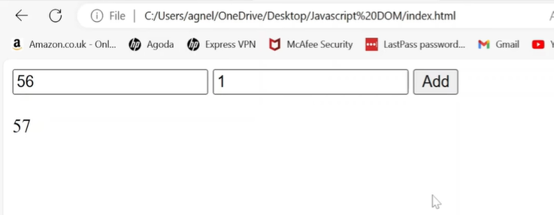

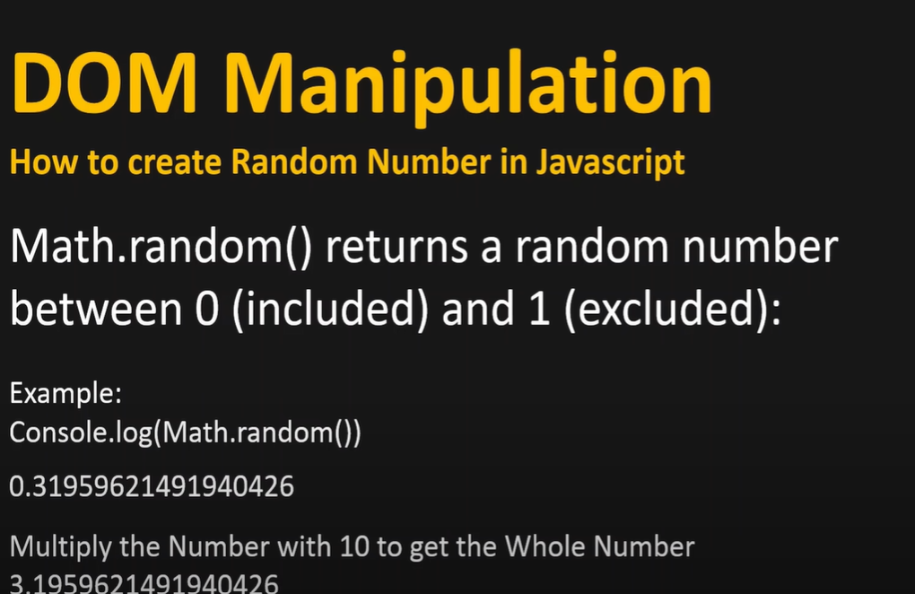

EXAMPLE:

**NOTE: Math.floor will give the single digit number before the point**

**Ex:** Math.random🡪2.3456788899

Math.floor 🡪2

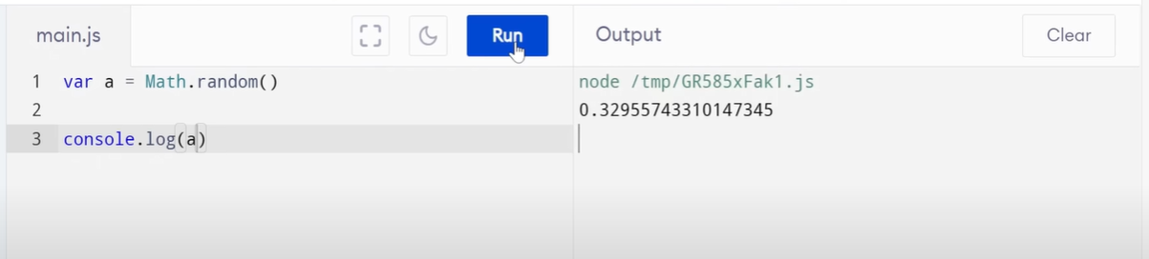

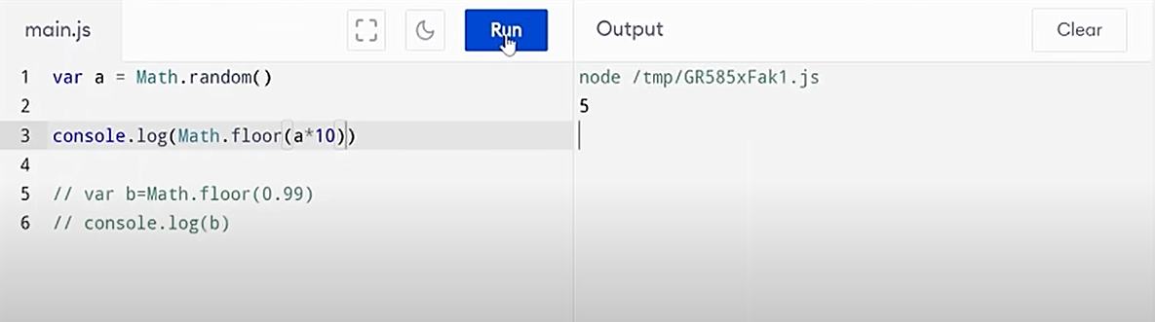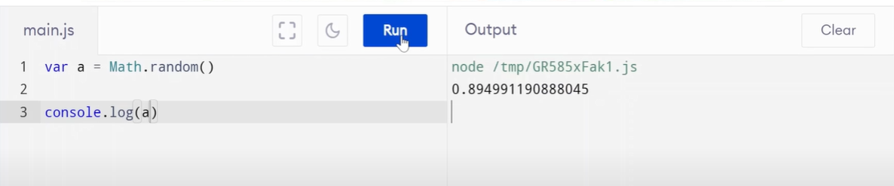

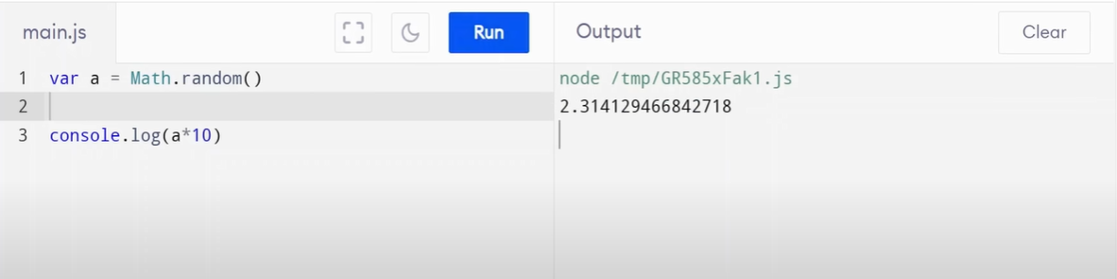

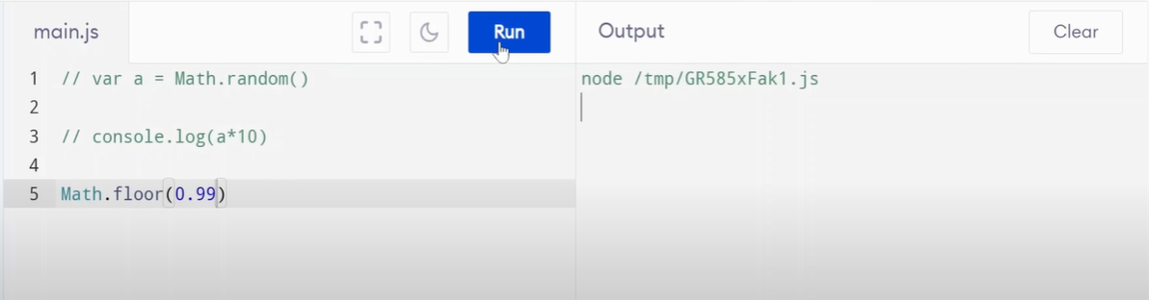

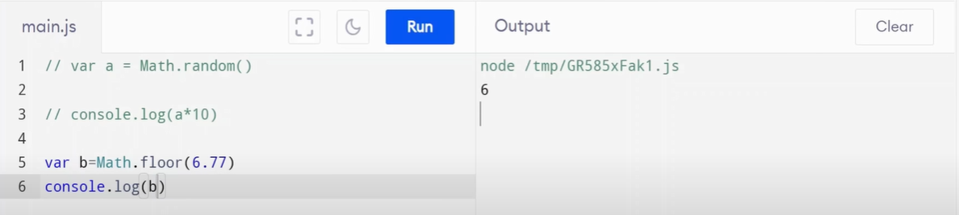

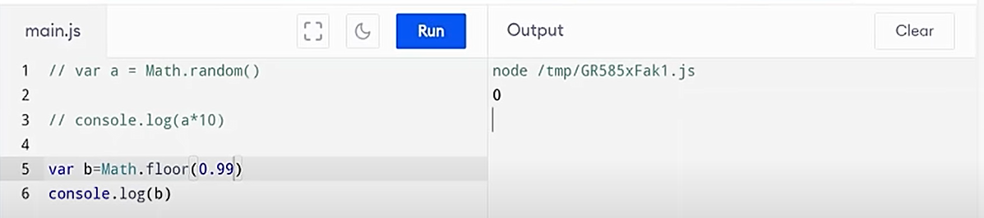

Example 2:

**Note :** if we want to generate random number 1 to 10 we should add +1.

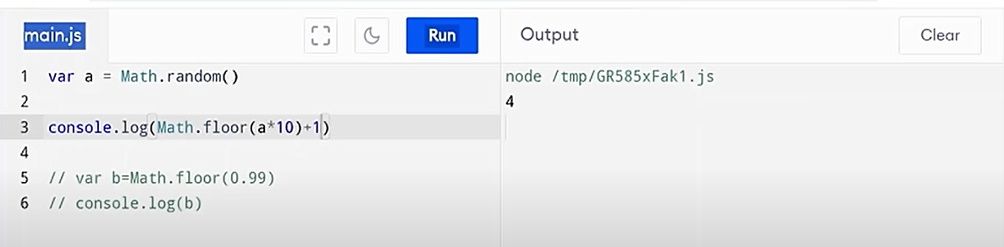

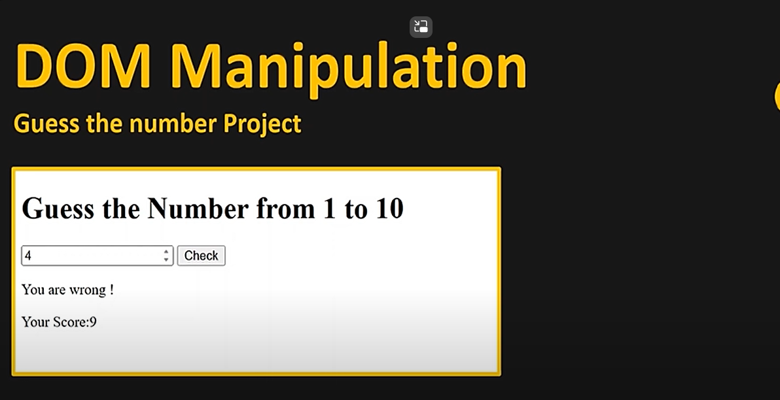

**ANSWER:** ["D:\javascript\index1.html"](index1.html)

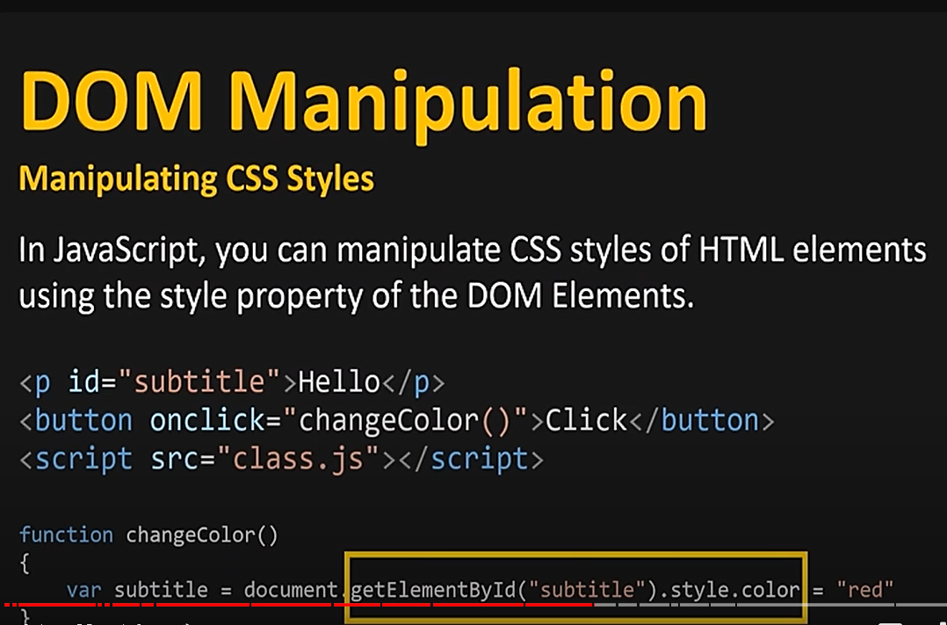

**ANS:** <index.html>

**TASK 1:**

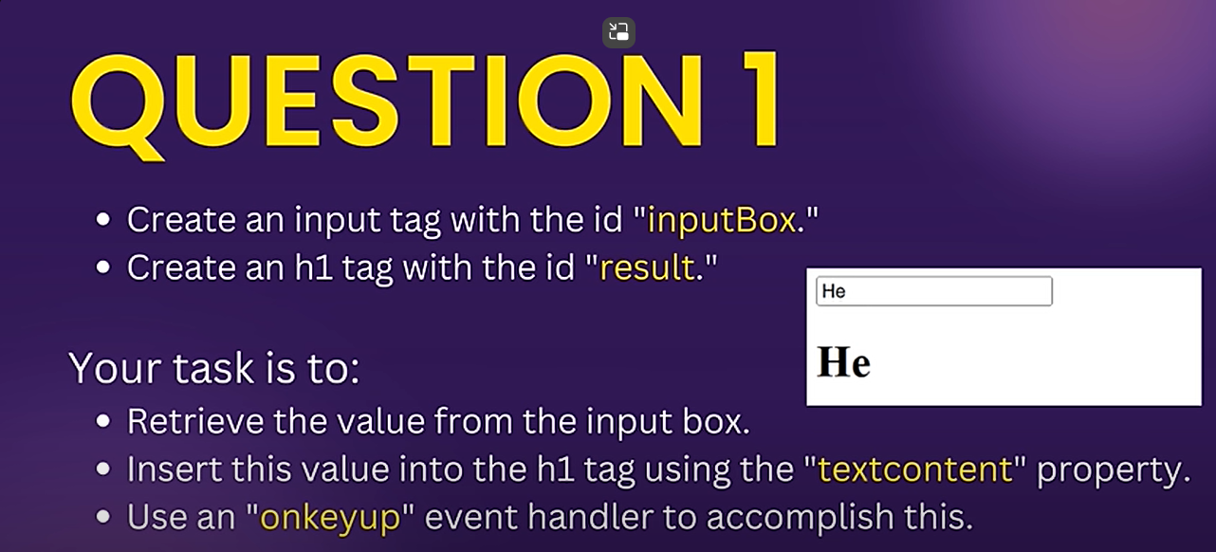

**ANSWER:** ["D:\javascript\Task1.html"](Task1.html)

**TASK 2:**

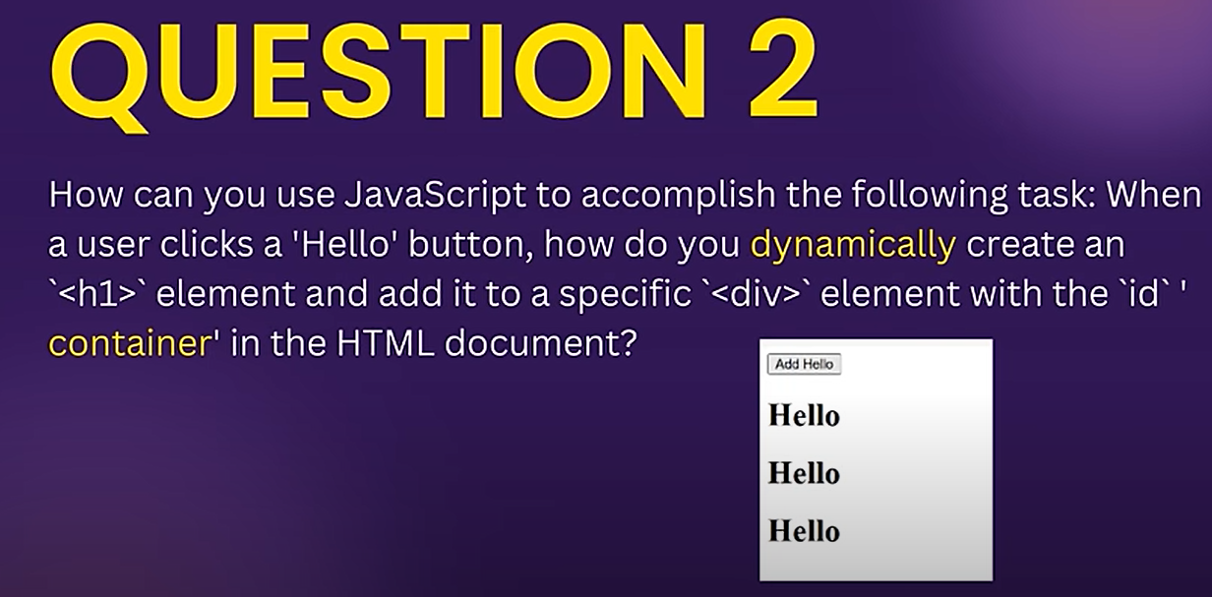

**ANSWER:** <Task2.html>

**TASK 3:**

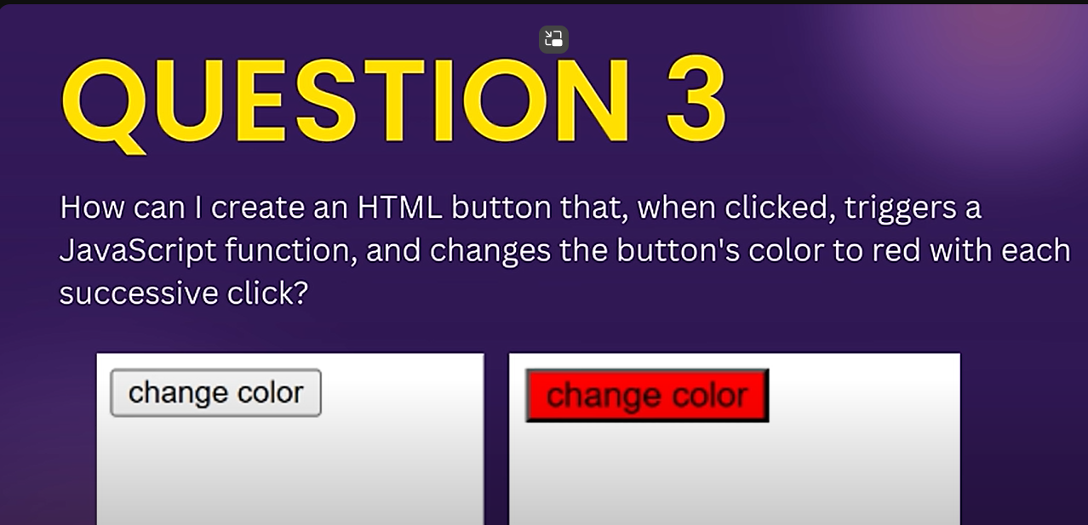

**ANSWER:**<Task3.html>

**TASK 4:**

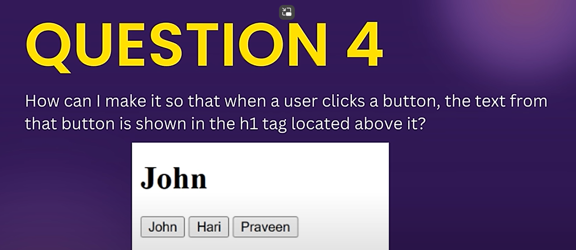

**ANSWER:** <Task4.html>

**TASK 5:**

Delete clicked one

ANSWER: <Task5.html>

**CREATE A TODO LIST**

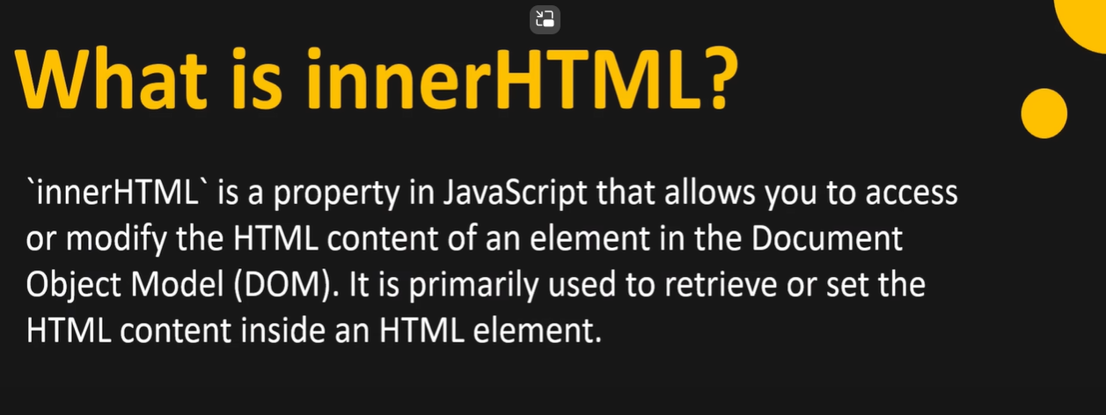

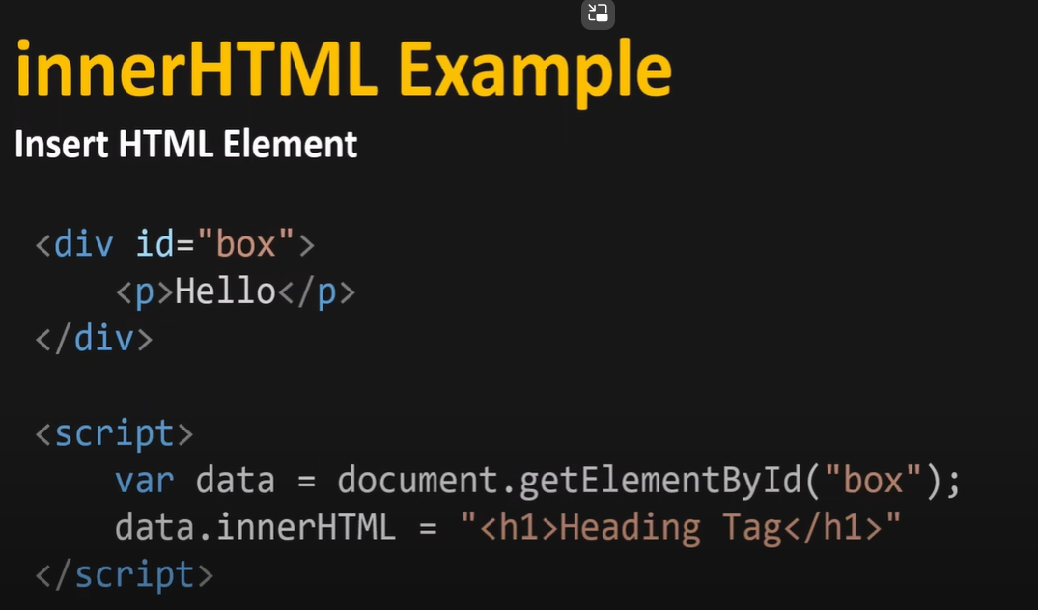

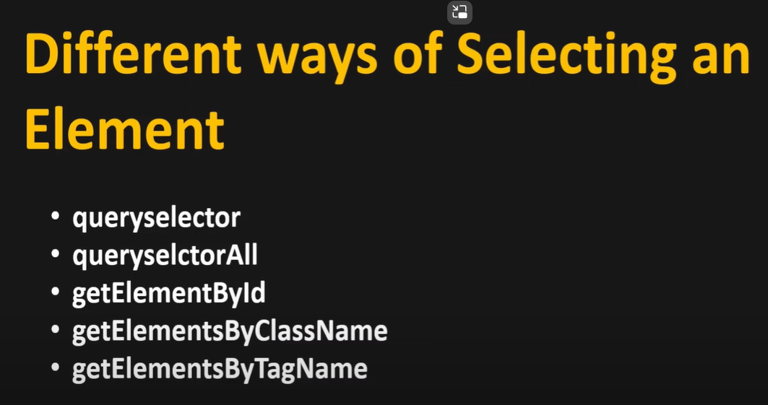

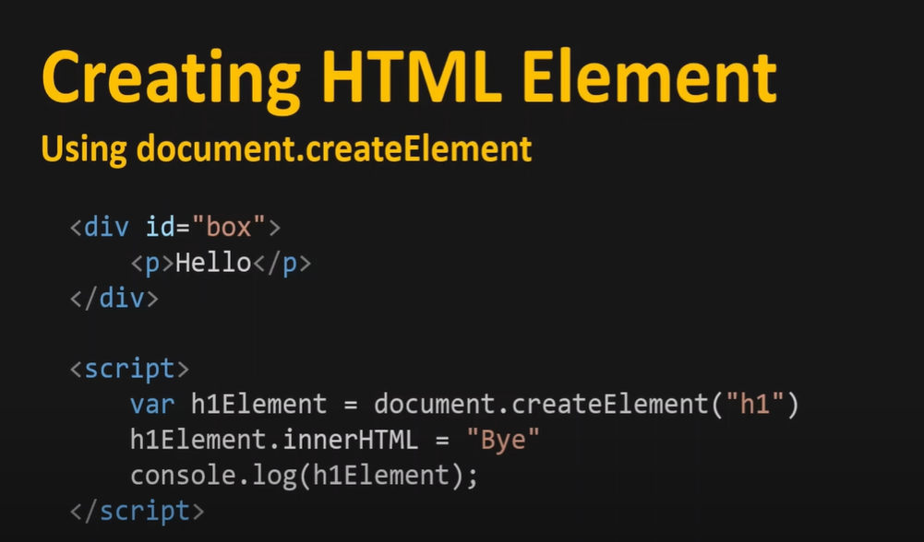

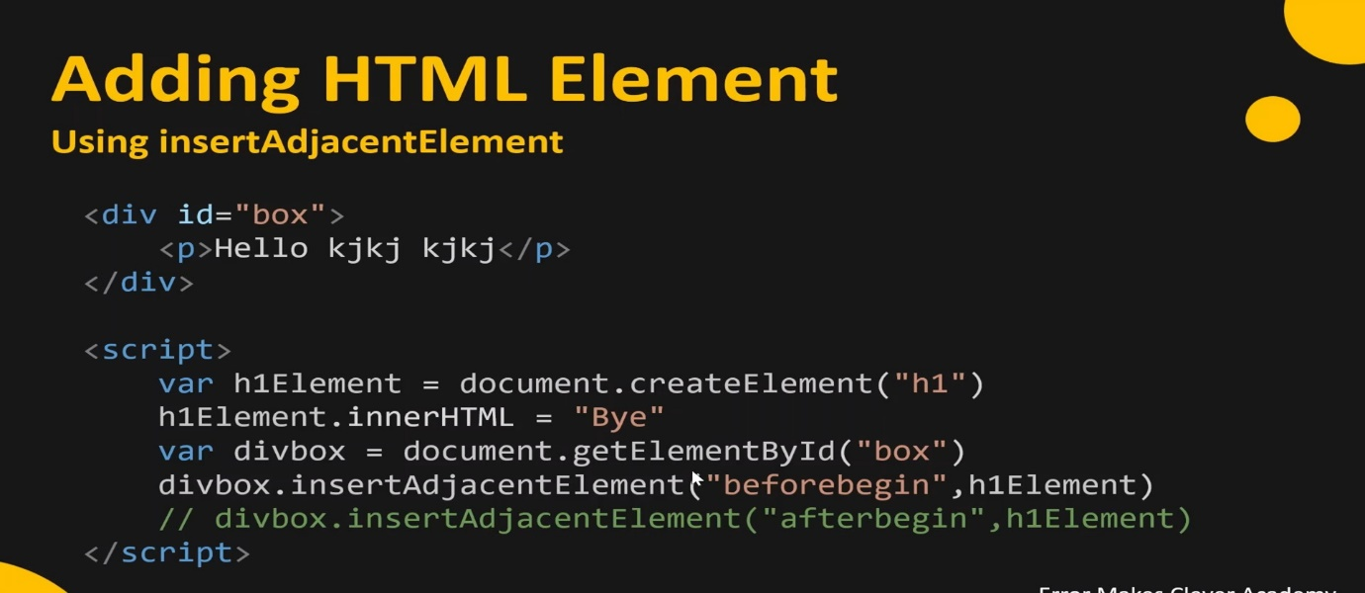

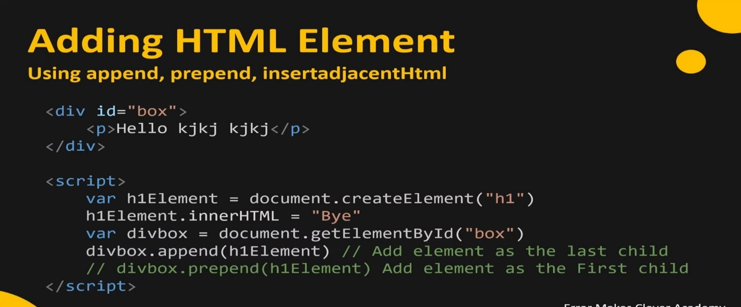

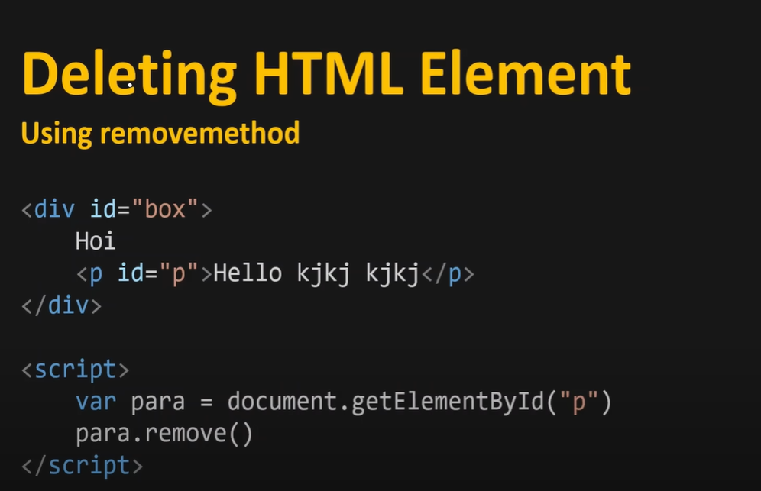

**TODO LIST:**<Todolist.html>

**BOOKLIST APP**

* <BookList.html>
* <script.js>
* <style.css>